Register with MobLab

Go to <https://game.moblab.com/server/register#student>, and fill in the required information. Make sure your password follows the regulation described beneath the input box, and solve the “Prove your humanity” math problem to proceed.

**IMPORTANT: To facilitate recordkeeping, use your university email address.**

Join the Class

Using a browser to sign into the Student Console. Click the “+” sign next to “My Classes” and enter our Class Code:

**<Insert Class Code>**

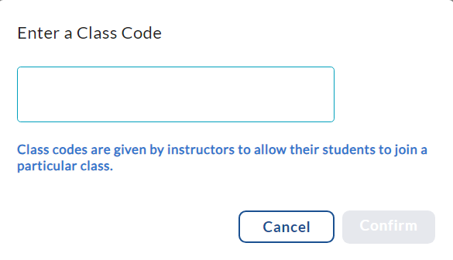

In the resulting popup, you will be prompted for the student fee which is payable by credit card. **If you received a textbook access code from the bookstore**, you can redeem it here. Once your payment or access code is processed, you should have confirmation that you have joined our class.

What do I need to participate?

To participate in MobLab games you need an internet-connected device, such as a Laptop, cellphone, or tablet. We recommend using a modern browser (such as Chrome) with the latest version to join the game.

Playing games

When instructed, access the Student Console in your browser. You will see your class’s session if your instructor has already started it. If not, wait for the session to start.

Have Questions?

If you have any questions or run into any issues, please email [support@moblab.com](mailto:support@moblab.com).

You may need to click the active session or refresh button (). To refresh the mobile app, simply pull down on your device’s screen. Once the session is visible, click ”Join” to join the session.  
  
