The steps below outline how students create a MobLab account with their Canvas school email to enable grade syncing. Please direct any questions to support@moblab.com.

- You will receive an invitation email from MobLab to sign-up for an account and join your class. Click “Sign Up Here” to create your account. | 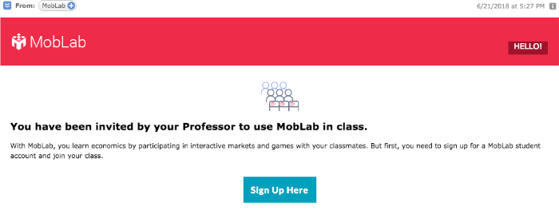
- Login to MobLab with an existing account, or create a new account with your Canvas school email address by entering a new password. | 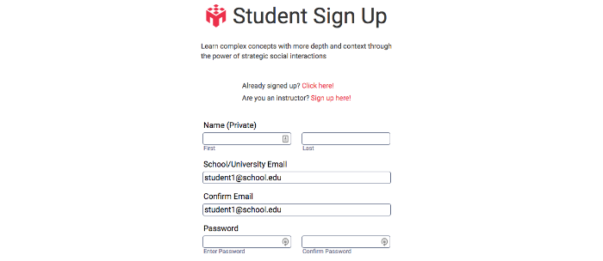
*Note: The email fields will be pre-filled with your primary Canvas School email. It’s essential you use this email for your grades to transfer between MobLab and Canvas.
- Join Your Class  If your institution has not paid for your student access, you will be prompted to pay for your student access by credit card or enter your student access code if purchased at the bookstore or bundled with your textbook.  If your institution has already paid for your student access, you should be done! No further action is needed to join your class. | 