Register with MobLab
Go to www.moblab.com, click ‘Sign Up’ to create a Student Account. You can also download the MobLab iOS or Android app and create your student account through the app.

IMPORTANT: To facilitate recordkeeping, use your university email address. You will be asked to verify your email before you can join your instructor’s class.
Join your Professor's Class
After creating your account, sign in and click on the + Button and enter our Class Code:

[Class Code]
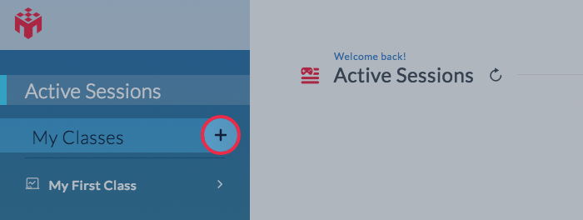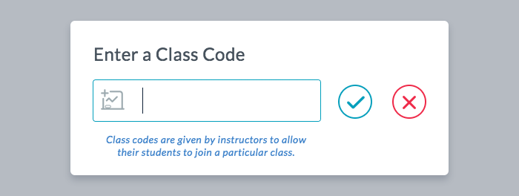

In the resulting popup, you will receive a confirmation that you have joined our class.

What do I need to participate?
To participate in MobLab games you need an internet-connected device. Laptop users can use any major browser. iOS (iPhone and iPad) and Android users must use the MobLab app downloadable from the device’s app store. Do not participate on a web browser on a mobile device.

Playing games
When instructed, access the Student Console in your browser or open the app on your iOS or Android device. You will see your class’s Active Session if your instructor has already started it. If not, wait for the session to start. You may need to click the Active Session link or refresh button. To refresh the mobile app, simply pull down on your device’s screen. Once the session is visible, click the playlist card.
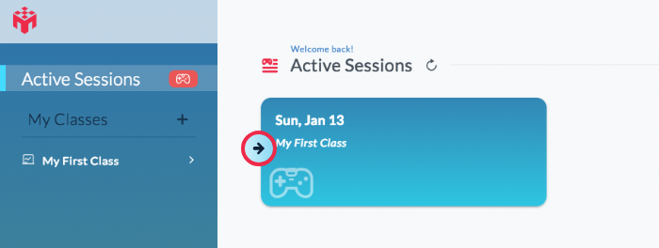
Have Questions?
If you have any questions or run into any issues, please email support@moblab.com.

